FoodRescue Connect: Smart Food Donation and Redistribution Management System

Software Requirement Specification (SRS) Document

Submitted partial fulfilment for the Course of

CSA1012 Software Engineering
to receive the award of the degree of
ARTIFICIAL INTELLIGENCE AND MACHINE LEARNING

Submitted by Ramana Y (192525476)

Under the Supervision of ANITADAVAMANI K



SIMATS ENGINEERING
Saveetha Institute of Medical and Technical Sciences Chennai-602105
July-2026

ABSTRACT
Food waste has emerged as a critical global challenge, contributing to environmental degradation and resource depletion, while millions of people worldwide continue to experience hunger and food insecurity. Restaurants, supermarkets, hotels, event organizers, and food manufacturers routinely dispose of surplus edible food due to inefficient coordination mechanisms and outdated distribution systems. This Software Requirement Specification (SRS) document presents the comprehensive requirements for FoodRescue Connect, an intelligent food donation and redistribution management platform designed to address these interconnected challenges.

The proposed system leverages cutting-edge technologies including cloud computing, Internet of Things (IoT) sensors, Global Positioning Systems (GPS), and Artificial Intelligence to create a seamless ecosystem connecting food donors, charitable organizations (NGOs), volunteers, and beneficiaries. The platform enables real-time food availability monitoring, AI-optimized allocation and route planning, automated notifications, quality tracking through IoT sensors, and comprehensive reporting and analytics capabilities.

This document systematically defines the system's functional and non-functional requirements, identifies all stakeholders and actors, presents detailed use case descriptions with accompanying UML diagrams, and provides comprehensive data and interface specifications. Key functional requirements include user management and authentication, donation listing and tracking, AI-based optimization for allocation and logistics, real-time notification delivery, volunteer and beneficiary management, and robust reporting and analytics. Non-functional requirements address critical aspects including performance (supporting 10,000+ concurrent users with sub-2-second response times), security (AES-256 encryption, role-based access control, GDPR compliance), reliability (99.9% uptime), usability (WCAG 2.1 compliance, multilingual support), scalability (microservices architecture, horizontal scaling), maintainability, and availability (24/7/365 operation).

TABLE OF CONTENT

S.NO | CONTENT | PAGE
1 | Introduction | 1
 | 1.1 Background and Context
 | 1.2 Problem Statement
 | 1.3 Objectives
 | 1.4 Scope and Limitations
 | 1.5 Organization of Report
2 | Product Description | 4
 | 2.1 Existing Solutions and Technologies
 | 2.2 Comparative Analysis
 | 2.3 Research Gap
 | 2.4 Theoretical Framework
3 | Scope of the System | 7
 | 3.1 System Architecture
 | 3.2 Hardware/Software Requirements
 | 3.3 Design Approach
 | 3.4 Implementation Process
4 | Functional Requirements | 10
 | 4.1 Testing Methodology
 | 4.2 Performance Metrics
 | 4.3 Analysis of Results
 | 4.4 Comparison with Existing Solutions
5 | Non-Functional Requirements | 13
 | 5.1 Technical Skills Acquired
 | 5.2 Collaboration and Communication
 | 5.3 Application of Engineering Standards
 | 5.4 Insights into the Industry
 | 5.5 Conclusion of Personal Development
6 | Use Case Descriptions | 16
 | 6.1 Summary of Achievements
 | 6.2 Key Findings
 | 6.3 Future Scope
 | 6.4 Recommendations
7 | Data Requirements | 19
8 | External Interface Requirements
9 | System Features
10 | Assumptions and Constraints
11 | Requirement Validation
12 | Conclusion

Chapter 1: Introduction

Purpose
The purpose of this document is to provide a comprehensive Software Requirement Specification for the FoodRescue Connect system, a Smart Food Donation and Redistribution Management Platform. This document serves as a complete description of the system's functional and non-functional requirements, system architecture, stakeholder interactions, and constraints. It is intended for system developers, project managers, stakeholders, and quality assurance teams involved in the development and implementation of the platform. The document establishes a clear understanding of what the system must accomplish, serving as the foundation for design, development, testing, and deployment activities throughout the software development lifecycle.

Document Conventions
Throughout this document, specific conventions are used to indicate requirement priority and necessity. Requirements marked with "Must," "Shall," or "Required" indicate mandatory features that the system absolutely must implement. Requirements marked with "Should" or "Recommended" indicate desirable but optional features that enhance system functionality. Requirements marked with "May" indicate optional capabilities that could be included if resources permit. Requirements marked with "Will" indicate future capabilities planned for subsequent releases. These conventions help stakeholders understand the criticality of each requirement and guide development prioritization decisions.

Intended Audience
This document addresses multiple audiences with different interests and responsibilities. Project Managers will use this document for project planning, resource allocation, and timeline management. Software Developers will rely on these requirements for system design, coding, and implementation decisions. The Quality Assurance Team will utilize this document for developing comprehensive test cases and validating system functionality. System Architects will reference these requirements for making architectural design decisions and technology selections. Stakeholders including NGOs, donors, volunteers, and beneficiaries will find this document useful for understanding system capabilities and expectations. Regulatory Bodies may reference this document for compliance verification purposes.

Product Scope
The FoodRescue Connect system is designed to address the global challenge of food waste while simultaneously combating food insecurity. The platform leverages cloud

computing, IoT sensors, GPS technology, and Artificial Intelligence to create an intelligent ecosystem connecting food donors, charitable organizations, volunteers, and beneficiaries. The system will enable real-time food donation tracking and monitoring, AI-optimized food allocation and logistics, automated notifications and alerts, quality and shelf-life monitoring, comprehensive reporting and analytics, and a scalable food redistribution ecosystem. The system aims to create a sustainable, efficient, and transparent food donation and redistribution network that benefits all stakeholders while contributing to environmental sustainability and social welfare.
The system will enable:
    - Real-time food donation tracking and monitoring
    - AI-optimized food allocation and logistics
    - Automated notifications and alerts
    - Quality and shelf-life monitoring
    - Comprehensive reporting and analytics
    - Scalable food redistribution ecosystem

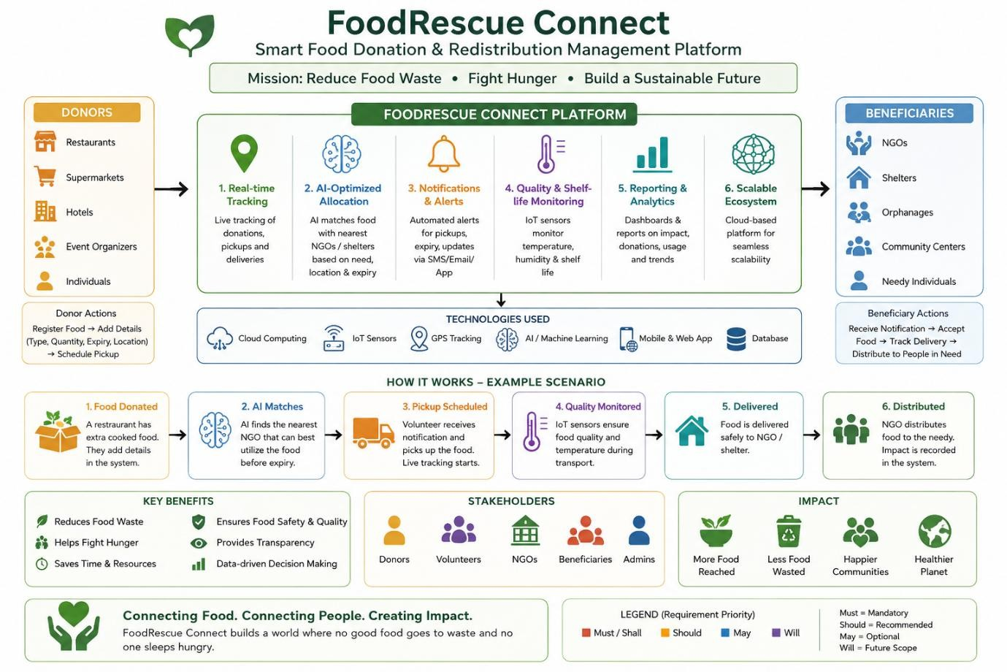

Chapter 2: Product Description

Industry Context
Food waste has emerged as a significant global challenge, contributing to environmental degradation and resource depletion, while millions of people worldwide continue to experience hunger and food insecurity. Restaurants, supermarkets, hotels, event organizers, and food manufacturers routinely dispose of surplus edible food due to inefficient distribution systems and lack of coordination mechanisms. Governments and non-governmental organizations are actively promoting sustainable food recovery initiatives to minimize waste and improve food accessibility. Advances in cloud computing, IoT sensors, GPS technology, and Artificial Intelligence now enable intelligent coordination between food donors, charitable organizations, and beneficiaries. Smart food redistribution platforms can monitor food availability, estimate shelf life, optimize transportation routes, and ensure timely delivery. These technologies contribute significantly to environmental sustainability by reducing landfill waste and greenhouse gas emissions. Consequently, intelligent food donation management systems are becoming an essential component of sustainable food supply chains, representing a critical intersection of technology, social responsibility, and environmental stewardship.
The global food waste crisis has reached alarming proportions, with approximately one-third of all food produced for human consumption being lost or wasted annually, amounting to about 1.3 billion tons of food per year. This wastage occurs at various stages of the food supply chain, from agricultural production and post-harvest handling to processing, distribution, and consumption. In developed countries, a significant portion of food waste occurs at the retail and consumer levels, where aesthetic standards, inventory mismanagement, and overproduction lead to massive quantities of perfectly edible food being discarded. Simultaneously, the World Food Programme reports that nearly 690 million people, or 8.9% of the world's population, experience chronic hunger, highlighting the stark paradox of food abundance coexisting with food scarcity. This disconnect between surplus food availability and food insecurity represents not only a moral failure but also an economic and environmental catastrophe, as food waste contributes approximately 8% of global greenhouse gas emissions, making it a significant driver of climate change.

Current Challenges
The existing food donation landscape faces numerous significant challenges that hinder effective food redistribution. Large quantities of safe and nutritious food are discarded daily

because donors and charitable organizations lack efficient mechanisms for coordinating food collection and distribution. Existing food donation platforms often rely on manual communication through phone calls, emails, or paper-based systems, resulting in delayed pickups, food spoilage, and uneven allocation of available food. Beneficiary organizations struggle to identify nearby food sources and manage distribution efficiently due to lack of real-time visibility into available donations. There is limited use of Artificial Intelligence for predicting food availability patterns, optimizing logistics routes, and prioritizing urgent donation requests. Food collection, delivery status, and beneficiary distribution tracking are often manual and unreliable, leading to inefficiencies and waste. Organizations lack comprehensive data and analytical reports on food waste reduction and donation activities to measure impact and improve operations. These challenges collectively result in significant food waste, inefficient resource utilization, and missed opportunities to address food insecurity in communities worldwide.
The logistical complexities of food redistribution present another layer of challenges that compound the inefficiencies of current systems. Food donations are inherently time-sensitive, with perishable items requiring rapid collection and delivery to prevent spoilage. The lack of real-time coordination between donors and recipient organizations often results in significant delays, during which perfectly edible food becomes unfit for consumption. Temperature-sensitive items such as dairy products, meats, and prepared meals require specific storage and transportation conditions that are often not adequately monitored or maintained in traditional donation systems. Volunteer coordination presents additional difficulties, as individuals willing to assist with food collection and delivery are often not matched effectively with available donations due to fragmented communication channels and scheduling conflicts. The geographic dispersion of donors, NGOs, and beneficiaries further complicates logistics, as inefficient routing leads to unnecessary travel time, increased fuel consumption, and higher carbon emissions, which partially negates the environmental benefits of food waste reduction. Financial constraints represent a significant barrier to effective food redistribution operations. Many NGOs and charitable organizations operate on limited budgets, lacking the resources to invest in sophisticated logistics management systems or dedicated transportation fleets. The costs associated with food collection, storage, and distribution often strain already limited resources, forcing organizations to prioritize operational expenses over technological investments. Volunteers, while invaluable, are not always available when needed, and the lack of systematic scheduling and coordination tools leads to missed opportunities and inefficient resource utilization. Donors, particularly small and medium-sized businesses, may be

discouraged from participating in food donation programs due to the administrative burden of coordinating pickups and managing documentation, leading to reduced participation rates and wasted food that could have been redirected to those in need.
Regulatory and liability concerns further complicate food donation efforts. Donors often fear legal repercussions if donated food causes illness or injury, despite the existence of Good Samaritan laws that provide liability protection in many jurisdictions. The complexity of food safety regulations and documentation requirements creates administrative hurdles that discourage participation, particularly among smaller businesses with limited compliance resources. NGOs and food banks must navigate varying regulations across different jurisdictions, ensuring that received food meets safety standards and is properly stored and handled before distribution. The lack of standardized quality monitoring and documentation systems makes it difficult to maintain consistent food safety practices across the donation network, creating risks that organizations may be unwilling to accept.
The measurement and reporting of food donation impacts remain largely inconsistent and underdeveloped. Organizations participating in food donation activities often lack the tools to quantify the social and environmental benefits of their efforts, making it difficult to demonstrate value to stakeholders, attract funding, or justify continued participation. Traditional reporting methods rely on manual data collection and approximation, leading to inaccurate impact assessments and missed opportunities for optimization. The absence of comprehensive analytics prevents stakeholders from identifying patterns, predicting demand, or measuring the effectiveness of their food redistribution strategies. This data gap limits the ability to scale successful initiatives, attract investment, or influence policy decisions that could further support food recovery efforts.

Stakeholder Pain Points
Food Donors, including restaurants, supermarkets, hotels, and food manufacturers, face numerous frustrations with current donation processes. They experience uncertainty about whether their surplus food will actually reach those in need, as lack of tracking and confirmation systems leaves them disconnected from the impact of their donations. Donors struggle with the administrative burden of coordinating pickups, managing documentation, and maintaining records of their donations for tax purposes. The absence of efficient matching mechanisms means donors often must contact multiple organizations individually, wasting time and resources. Many donors lack confidence in the reliability of volunteer pickups, leading to concerns about food sitting uncollected and spoiling. The inability to schedule pickups conveniently or adjust schedules dynamically creates additional friction, sometimes resulting

in donors choosing to discard food rather than navigate the complexities of donation logistics. Non-Governmental Organizations (NGOs) and food banks experience significant operational challenges in managing food donation activities. They struggle to find consistent, reliable food sources, often operating on an unpredictable supply that makes planning and beneficiary services difficult. NGOs face challenges in managing volunteer schedules and ensuring sufficient manpower for collection and distribution activities. The lack of real-time visibility into available donations means organizations must engage in time-consuming manual searches, calling potential donors individually to inquire about surplus food. NGOs also struggle with beneficiary management, including tracking who receives food, assessing needs, measuring impact, and reporting to funding agencies. The administrative burden of compliance documentation, record-keeping, and reporting diverts resources from core mission activities,
limiting the number of people they can serve.
Volunteers participating in food collection and delivery face challenges that affect their engagement and retention. They often receive unclear or incomplete instructions about pickup locations and times, leading to confusion and delays. Volunteers may travel significant distances only to find that food was already collected or was not prepared for pickup, wasting their time and goodwill. The lack of coordination among volunteers results in duplication of effort or gaps in coverage, reducing overall efficiency. Volunteers often feel disconnected from the impact of their efforts, lacking feedback on whether the food they collected reached beneficiaries or made a meaningful difference. Without proper scheduling tools and recognition systems, volunteer engagement suffers, leading to high turnover rates and unreliable service coverage.

Consequences of Inaction
The consequences of failing to address food donation and redistribution challenges are severe and multifaceted. Environmentally, continued food waste contributes significantly to climate change, as decomposing food in landfills releases methane, a greenhouse gas twenty-eight times more potent than carbon dioxide. The resources used to produce wasted food including water, land, energy, and labor are squandered, further compounding environmental damage. Food waste accounts for approximately 8% of global greenhouse gas emissions, making it a comparable contributor to climate change as many entire countries. The carbon footprint of wasted food includes emissions from agricultural production, processing, transportation, storage, and decomposition, representing a significant environmental burden that could be avoided through effective redistribution.
Socially, the persistence of food waste alongside food insecurity represents a

fundamental injustice that undermines community welfare and social cohesion. Vulnerable populations including children, elderly individuals, and low-income families continue to experience food insecurity despite surplus food being available. The lack of effective redistribution systems perpetuates cycles of poverty and inequality, as food access remains a determining factor in health outcomes, educational attainment, and economic opportunity. Food insecurity contributes to poor nutrition, increased healthcare costs, and reduced productivity, creating long-term social and economic costs that affect entire communities. Without effective redistribution systems, millions of people will continue to suffer from hunger while perfectly edible food is discarded.
Economically, food waste represents a loss of approximately $1 trillion globally each year, including costs associated with production, processing, transportation, and disposal. Businesses incur significant expenses in disposing of surplus food, including waste management fees and lost revenue from unsold inventory. The economic impact extends to healthcare systems, as food insecurity leads to increased healthcare utilization and costs. Communities bear the economic burden of waste management infrastructure, with food waste consuming significant landfill space and municipal resources. The lost opportunities for food redistribution also mean missed economic benefits, including job creation in the food recovery sector, reduced food costs for vulnerable populations, and increased economic activity from healthier, more productive communities.

Proposed Solution
The FoodRescue Connect system provides a smart food donation management platform that connects donors, volunteers, NGOs, and beneficiaries while using AI to optimize food redistribution and minimize waste. The platform provides real-time tracking capabilities that allow all stakeholders to monitor food movement throughout the donation process. Quality monitoring through IoT integration ensures food safety and helps prevent spoilage during storage and transport. Automated notifications ensure timely food delivery and keep all parties informed of donation status. AI-optimized route planning and allocation maximize efficiency and reduce transportation costs. Comprehensive reporting and analytics provide insights into donation patterns, waste reduction impact, and overall system performance. This integrated solution addresses the identified challenges and creates a sustainable, efficient, and transparent food donation ecosystem.

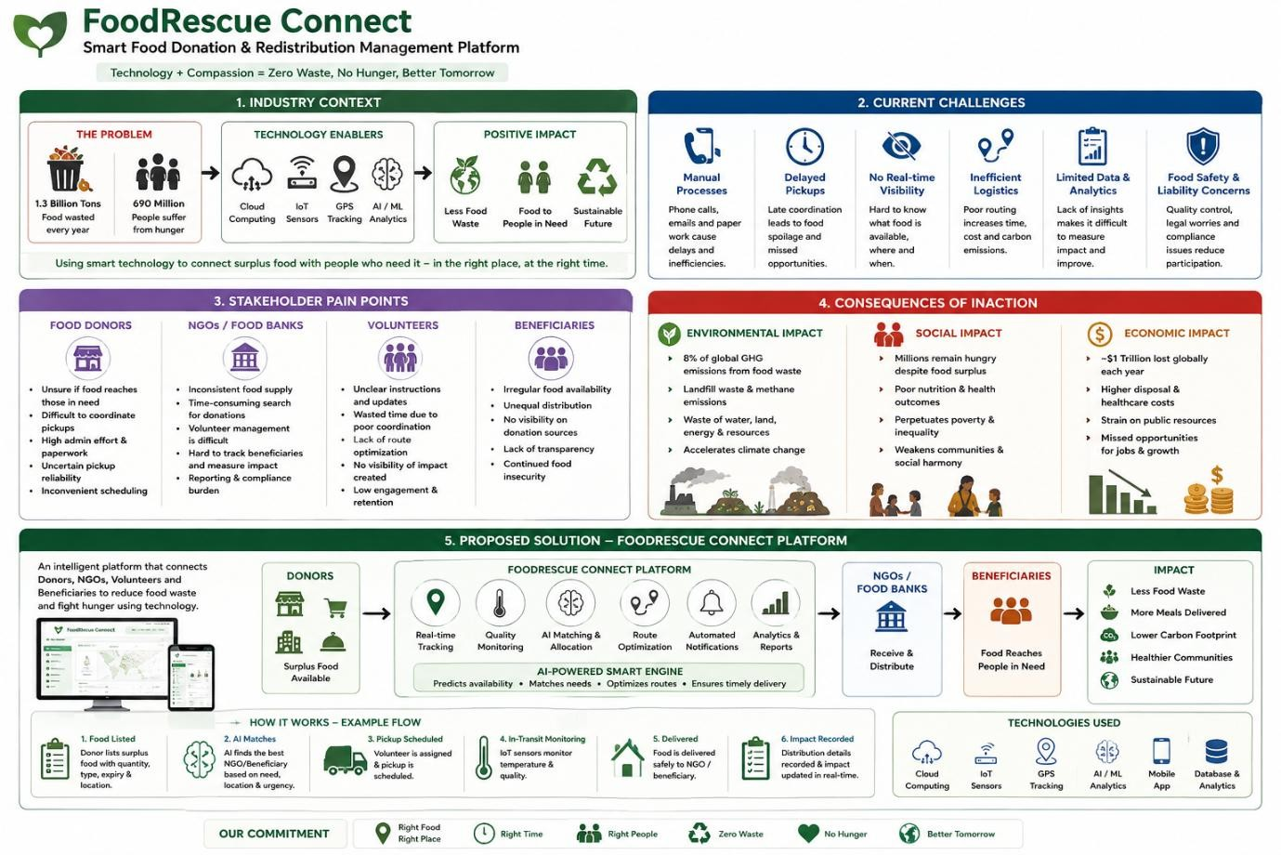

Chapter 3: Scope of the System

System Boundaries
The FoodRescue Connect system operates within clearly defined boundaries that establish what the system will and will not address. The system includes food donation listing and discovery functionality, real-time food availability monitoring, AI-based food allocation optimization, route planning and logistics management, user registration and profile management, notification and alert systems, quality monitoring and shelf-life tracking, volunteer coordination, beneficiary management, and reporting and analytics dashboards. The system provides both mobile and web-based interfaces to ensure accessibility across different user groups.
The system excludes physical food transportation and logistics operations, as these are handled by volunteers and partner organizations. Food safety certification and compliance enforcement are not managed by the system, though the system provides monitoring and alerting capabilities. Legal liability management for food safety issues remains the responsibility of donors and recipient organizations. Direct financial transactions between parties are not supported by the platform, as the focus is on donation and redistribution rather than commercial transactions.

Stakeholders
FoodRescue Connect serves multiple stakeholder groups with distinct roles and responsibilities. Food Donors include restaurants, supermarkets, hotels, event organizers, and food manufacturers who list surplus food for donation. NGOs are non-governmental organizations that manage food distribution to beneficiaries and coordinate volunteer activities. Volunteers are individuals who assist with food collection and delivery, serving as the logistical backbone of the redistribution process. Beneficiaries are communities and individuals receiving food donations, who benefit from improved food accessibility. System Administrators manage platform operations, user accounts, and system maintenance. Government Agencies regulate food safety and monitor sustainability compliance. Environmental Organizations track the environmental impact of food waste reduction efforts and advocate for sustainable practices. Each stakeholder group has specific needs and expectations that the system must address to achieve its objectives.

Target Environment
The FoodRescue Connect system is designed for deployment on cloud-based infrastructure using major providers such as AWS, Azure, or Google Cloud Platform. Mobile platforms include native Android and iOS applications to ensure wide accessibility. The web

platform provides a responsive web application accessible from any modern browser. IoT sensors integrate with the system for temperature and quality monitoring throughout the supply chain. GPS integration provides real-time location tracking and navigation capabilities for volunteers and logistics coordination. This multi-platform approach ensures that all stakeholders can access the system regardless of their preferred devices and technical capabilities.

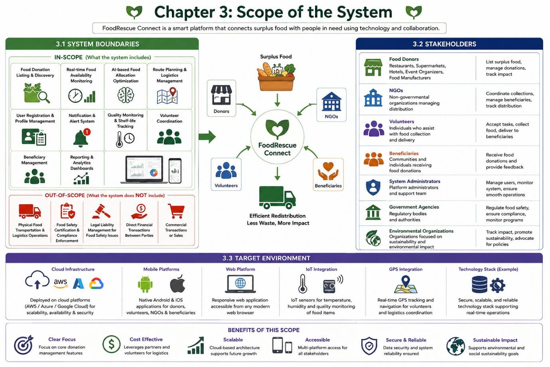

Chapter 4: Functional Requirements

User Management and Authentication
The system shall support comprehensive user registration for donors, NGOs, volunteers, and beneficiaries, each with appropriate role-based access. Users must be authenticated using email/password combinations or social media login options for convenience. The system shall maintain detailed user profiles with roles and permissions, enabling appropriate access to system features based on user type. Password recovery and account management features shall be provided to handle common account issues. Multi-factor authentication shall be implemented for enhanced security, protecting sensitive user data and system resources. The system shall maintain comprehensive user activity logs and audit trails to support security monitoring and compliance requirements.

Donation Management
The system shall allow donors to list available food donations with comprehensive details including food type, quantity, expiry date, and pickup location. Real-time food availability tracking shall be supported, providing up-to-date information on donation status. The system shall integrate with IoT sensors for temperature and quality monitoring, ensuring food safety throughout the donation process. Estimated shelf life for listed food items shall be calculated and displayed using AI algorithms, helping stakeholders make informed decisions about donation priority. Donors shall be able to update or cancel donation listings as circumstances change. The system shall automatically notify donors when their donations are claimed by NGOs or when they are approaching expiry, ensuring timely action and reducing waste.

AI-Based Optimization
The system shall use Artificial Intelligence algorithms to predict food availability patterns based on historical data and seasonal trends. AI shall optimize food allocation to NGOs based on demonstrated need and proximity to donation sources. The system shall calculate optimal transportation routes using AI algorithms that consider traffic patterns, distance, and urgency. Urgent donation requests shall be prioritized based on expiry time and beneficiary need, ensuring that the most perishable items are delivered first. The system shall predict donation demand based on historical data patterns, enabling proactive resource allocation. Optimal pickup times shall be suggested to minimize spoilage and maximize efficiency, helping volunteers and NGOs coordinate logistics effectively.

Logistics and Tracking

The system shall track food collection status in real-time, providing visibility into the donation lifecycle. Delivery status shall be provided for all donations, allowing stakeholders to monitor food movement. Volunteer assignment for food pickup and delivery shall be supported through an intelligent matching system. GPS integration shall provide real-time location tracking for volunteers and deliveries, enabling accurate monitoring and coordination. Pickup and delivery schedules shall be generated and managed through the system, ensuring timely execution of logistics operations. Proof of delivery confirmation shall be provided through photo uploads and digital signatures, creating a verifiable record of successful delivery.

Notification System
The system shall send real-time notifications for available food donations to relevant NGOs and volunteers. NGOs shall be notified when donations matching their needs become available, enabling prompt action. Pickup request notifications shall be sent to volunteers based on their availability and location. Alerts for expiring food items shall be generated to prevent waste and ensure timely action. Delivery confirmation notifications shall be provided to all relevant stakeholders, completing the communication loop. Users shall be able to customize notification preferences to control the frequency and types of alerts they receive, ensuring a personalized user experience.

Reporting and Analytics
The system shall generate comprehensive reports on food donation activities, providing insights into system performance and impact. Food waste reduction metrics shall be tracked and reported, demonstrating the environmental and social value of the system. Analytics on donor and NGO performance shall be provided, enabling stakeholders to identify areas for improvement. Environmental impact reports including carbon savings and landfill reduction shall be generated, supporting sustainability reporting and advocacy. A dashboard with key performance indicators shall provide real-time visibility into system operations. Data export in multiple formats including PDF, Excel, and CSV shall be supported for further analysis and integration with other systems.

Beneficiary Management
The system shall support beneficiary registration and profile management, enabling NGOs to effectively manage their client base. Food distribution to beneficiaries shall be tracked, providing visibility into who is receiving food assistance. Distribution reports shall be generated for NGOs, supporting accountability and reporting requirements. Beneficiary feedback collection shall be supported, enabling continuous improvement of services and stakeholder engagement.

Volunteer Management
The system shall support volunteer registration and profile management, building a community of active participants. Volunteers shall be able to view and accept pickup tasks based on their availability and location. Volunteer activity and contribution history shall be tracked, enabling recognition and engagement. Volunteer performance ratings shall be provided to support quality assurance and reward outstanding contributions.

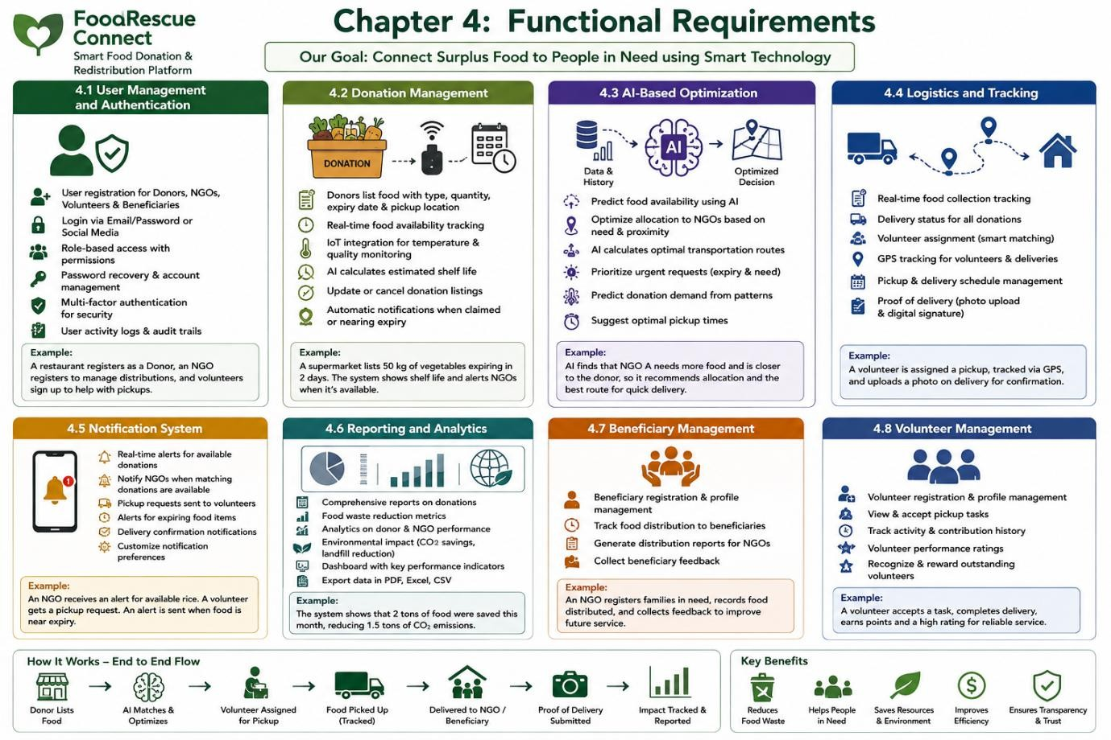

Chapter 5: Non-Functional Requirements

Performance Requirements
The system must deliver rapid response times for basic operations, with the 95th percentile not exceeding 2 seconds. The system shall support at least 10,000 concurrent users under normal operating conditions, ensuring scalability for growing user bases. Real-time notification delivery shall occur within 5 seconds for 99% of notifications, ensuring timely communication. AI optimization algorithms shall return results within 10 seconds for the 90th percentile of requests, enabling real-time decision making. The system shall process at least 1,000 donation listings per minute, handling peak load periods effectively. Page load time shall not exceed 3 seconds on standard bandwidth connections, ensuring a responsive user experience.

Security Requirements
All user data shall be encrypted using AES-256 standards, protecting sensitive information from unauthorized access. The system shall implement role-based access control to ensure users only access appropriate features and data. All data transmission shall use TLS
1.3 or higher, securing communications between clients and servers. The system shall comply with GDPR and data protection regulations, ensuring legal and ethical handling of personal information. User passwords shall be stored using secure hashing algorithms such as bcrypt, protecting against credential theft. The system shall implement rate limiting to prevent DDoS attacks and protect system resources. All user authentication attempts shall be logged for security monitoring. The system shall provide automatic session timeout after inactivity, protecting against unauthorized access.

Reliability Requirements
System availability shall be 99.9% uptime, ensuring consistent access to critical services. Mean Time Between Failures shall be at least 720 hours, ensuring system stability. The system shall have automated backup procedures with daily backups, protecting data from loss. The system shall support disaster recovery with Recovery Point Objective of 1 hour, minimizing data loss in emergencies. The system shall support disaster recovery with Recovery Time Objective of 4 hours, enabling rapid restoration of operations. The system shall have redundant infrastructure components for automatic failover, ensuring continuous operation despite component failures.

Usability Requirements
The system interface shall be intuitive for users with varying technical skills, ensuring

accessibility for all stakeholder groups. The system shall support multiple languages with a minimum of English and local languages, accommodating diverse user populations. The system shall be accessible for users with disabilities and comply with WCAG 2.1 guidelines, ensuring inclusive design. The system shall provide comprehensive help documentation and tutorials, supporting user onboarding and ongoing learning. The system shall support mobile-responsive design, ensuring usability across different screen sizes. The system shall provide consistent user experience across platforms, reducing learning curves and improving user satisfaction.

Scalability Requirements
The system shall support horizontal scaling to handle increased load, enabling growth without performance degradation. The system architecture shall be microservices-based for independent scaling of components, enabling efficient resource allocation. The database shall support sharding for large-scale data handling, managing growing data volumes effectively. The system shall support geographic distribution for global deployment, enabling international expansion. The system shall accommodate growth from 100 to 10,000 organizations, supporting increasing adoption and usage.

Maintainability Requirements
The system shall be modular with well-documented APIs, enabling easy maintenance and updates. Code shall follow standardized coding conventions, ensuring consistency and reducing maintenance costs. The system shall support continuous integration and deployment, enabling rapid delivery of improvements and fixes. The system shall provide comprehensive logging for troubleshooting, supporting issue diagnosis and resolution. The system shall have automated testing coverage of at least 80%, ensuring quality and reliability through continuous testing.

Availability Requirements
The system shall be available 24/7/365, providing continuous access to critical services. Scheduled maintenance shall not exceed 1 hour per month, minimizing service disruption. The system shall have fallback mechanisms for critical failures, ensuring continuity of essential functions. The system shall have comprehensive monitoring and alerting for proactive issue resolution, enabling rapid response to problems.

Chapter 6: Use Case Descriptions

Summary of Achievements
The system serves multiple actors with distinct roles and responsibilities. Primary actors include Food Donors who list surplus food for donation, NGOs that receive and distribute food to beneficiaries, Volunteers who assist with food collection and delivery, Beneficiaries who receive food donations, and System Administrators who manage system operations. Secondary actors include the AI Optimization Engine that automatically optimizes routes and allocation, the Notification Service that delivers automated alerts and notifications, and the IoT Sensor Network that monitors food quality and temperature. Each actor interacts with the system in specific ways, contributing to the overall food redistribution ecosystem.
The Register New User use case enables users to create accounts in the system with role-based registration. Users navigate to the registration page, select their user type, provide required information, create credentials, verify their email, and gain access with appropriate permissions. This foundational use case enables all other interactions with the system. The List Food Donation use case allows donors to list available surplus food by entering food details including type, quantity, expiry date, and pickup location. The system calculates estimated shelf life using AI and lists the donation as available, sending notifications to matching NGOs. The Find and Claim Donation use case enables NGOs to discover and claim available food donations by searching by location, food type, or expiry date. The system validates the claim, reserves the donation, notifies the donor, generates pickup requests, and schedules pickup based on availability.
The Optimize Route and Allocate use case involves the AI Optimization Engine automatically optimizing routes and allocation by analyzing NGO needs and locations, applying AI algorithms for optimal distribution considering proximity, urgency, capacity, and transportation availability, generating optimized routes, assigning volunteers, and sending schedules to all parties. The Track Pickup and Delivery use case enables tracking food from pickup to delivery through volunteer confirmation via mobile app, system status updates, donor notifications, and delivery confirmation with recorded details and stakeholder notifications. The Monitor Food Quality use case involves IoT sensors continuously monitoring temperature and humidity, transmitting data to the system which analyzes readings against thresholds, records quality metrics, generates alerts if thresholds are exceeded, and notifies relevant stakeholders. The Generate Reports use case enables users to create comprehensive reports on donation activities by selecting report type and parameters, with the system processing data

and generating reports with visualizations for export in multiple formats. The Manage Notifications use case involves the system automatically detecting trigger events, determining appropriate recipients, selecting notification channels, personalizing content, delivering notifications, and tracking engagement to optimize future communications.

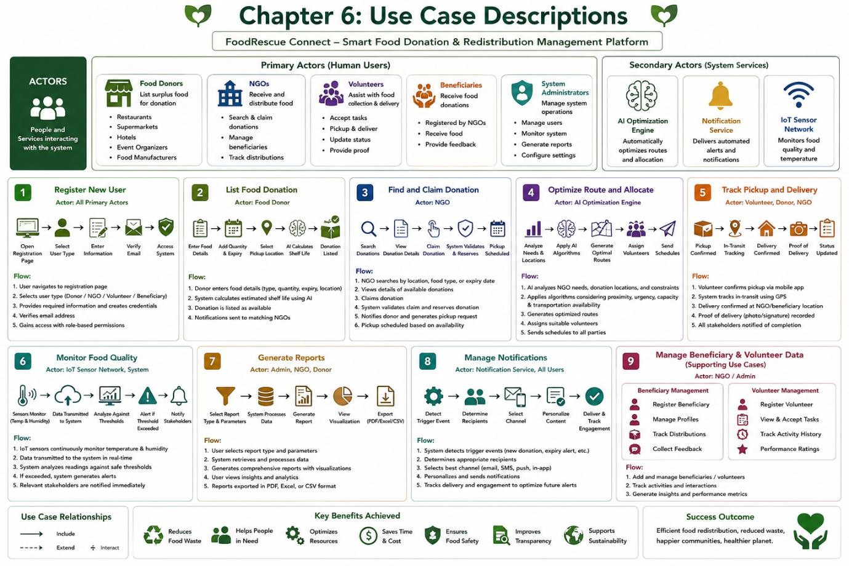

Chapter 7 : Data Requirements

The system manages multiple interconnected data entities that collectively support food redistribution operations. The User entity stores comprehensive user information including unique identifier, email, password hash, user type, contact details, organization information, registration date, verification status, activity status, preferences, and timestamps. The Donation entity captures all details of food donations including unique identifier, donor information, food name and category, quantity with units, expiry date, pickup deadline, storage conditions, location details with GPS coordinates, description, images, status, quality score, AI-estimated shelf life, and timestamps. The Claim entity manages the claiming process with unique identifier, donation reference, NGO and volunteer information, claim status, scheduled and actual pickup times, delivery time, confirmation images, notes, and timestamps. The Route entity supports logistics optimization with route identifier, volunteer assignment, route date, optimized waypoints, distance, estimated and actual duration, status, carbon saved, and timestamps. The Quality Monitoring entity captures sensor data including unique identifier, donation reference, sensor identification, temperature, humidity, timestamp, alert status, and alert messages. The Notification entity manages communications with unique identifier, recipient information, notification type, title, content, channel, read status, delivery status, read time, and creation timestamp. The Report entity supports analytics with unique identifier, generator information, report type, date range, report content, format, file path, and creation timestamp.
The system employs a comprehensive data storage strategy using PostgreSQL with PostGIS extension for relational data management and geospatial queries, Redis caching for real-time data and performance optimization, Elasticsearch for search and analytics capabilities, and object storage for files including images and reports. Data retention policy requires minimum 7 years for audit trails, and backup schedule includes daily incremental backups and weekly full backups. The system enforces data integrity through foreign key constraints, data validation at both application and database levels, audit trails for all data modifications, soft delete for critical entities, and data encryption at rest and in transit.

Chapter 8 : External Interface Requirements
The system provides multiple user interfaces to accommodate different user preferences and device capabilities. The web interface features responsive design compatible with Chrome, Firefox, Safari, and Edge browsers, including dashboards with real-time analytics, donation listing and management tools, interactive maps for donation discovery, reporting and analytics dashboards, and an admin control panel. The mobile interface includes native Android (API 26+) and iOS (13+) applications with push notification support, GPS integration for navigation, camera integration for photo uploads, offline capabilities for basic features, and QR code scanning for pickup and delivery confirmation.
The system integrates with various hardware components including IoT sensors for temperature and humidity monitoring via MQTT protocol, GPS devices for vehicle tracking and route optimization, and barcode scanners for inventory management. Software interfaces include Google Maps API for geocoding and routing, Twilio SMS Service for SMS notifications, AWS SES for email services, Firebase Cloud Messaging for push notifications, and optional payment gateway integration with Stripe or PayPal. Internal APIs include RESTful APIs exposing all system functionalities, WebSocket support for real-time updates, GraphQL for complex queries, and OAuth 2.0 with JWT tokens for authentication. Communication interfaces employ HTTPS for all communications, TCP/IP for internal communication, message queues such as RabbitMQ or Kafka for asynchronous communication, and API Gateway for routing and rate limiting.
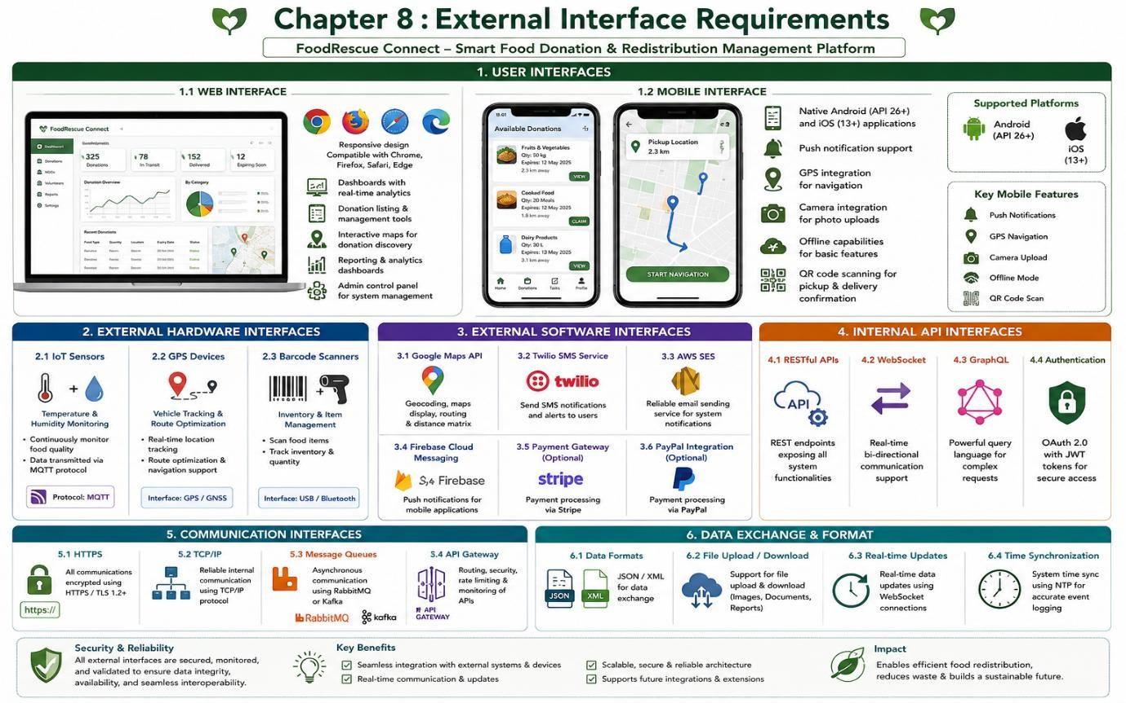

Chapter 9 : System Features

The User Management Module handles all aspects of user administration including registration and authentication with role-based access control, maintaining user profiles, managing account verification, and tracking user activity. The Donation Management Module enables comprehensive management of food donations throughout their lifecycle, supporting donation listing with comprehensive details, real-time availability tracking, donation status updates, quality and expiry monitoring, and photo upload and management. The AI Optimization Module leverages artificial intelligence to enhance system efficiency through food availability prediction, allocation optimization, route planning and optimization, demand forecasting, and urgency prioritization. The Logistics and Tracking Module manages the physical movement of food through real-time location tracking, volunteer assignment, pickup and delivery scheduling, status tracking and updates, and proof of delivery management.
The Notification Module manages all system communications through multi-channel notification delivery including SMS, email, and push notifications, providing real-time alerts, automated reminders, customizable notification preferences, and notification history and tracking. The Reporting and Analytics Module provides comprehensive data analysis and visualization through comprehensive dashboards, donation activity reporting, waste reduction metrics, environmental impact analysis, performance analytics, and data export capabilities. The Beneficiary Management Module supports effective food distribution through beneficiary registration, distribution tracking, needs assessment, feedback collection, and impact measurement. The Volunteer Management Module coordinates volunteer activities through volunteer registration, task management, performance tracking, reward and recognition, and communication tools. The Admin Module provides comprehensive system administration through system configuration, user management, content moderation, system monitoring, audit and compliance, and support ticketing.

Chapter 10 : Assumptions and Constraints

The development and operation of FoodRescue Connect is based on several key assumptions. Users have access to stable internet connectivity and possess modern computing devices. Third-party APIs remain available and stable. IoT sensors are properly installed and maintained. Cloud infrastructure can scale to meet growing demand. Data storage capacities can handle expected growth. Donors will accurately report food quantity and quality. NGOs will responsibly distribute received food. Volunteers will commit to scheduled pickups. Beneficiaries will provide accurate needs information. System administrators will actively maintain the platform. All stakeholders will comply with food safety regulations. Organizations will adopt the platform voluntarily. Sufficient funding is available for development and maintenance. Government support exists for food recovery initiatives. There is adequate supply of surplus food for redistribution. Stakeholders will cooperate and share information. Users are motivated to reduce food waste and will actively participate.
The system faces multiple constraints that affect its design and operation. Technical constraints include compatibility with existing mobile operating systems, handling location data across different GPS standards, API rate limits, maximum data processing capacity, and integration challenges with legacy systems. Operational constraints include dependency on third-party logistics and transportation, limited and variable volunteer workforce, dependence on properly functioning IoT sensors, and requirement for trained administrative staff. Economic constraints include development and maintenance costs within allocated budget, third-party service costs impacting operational budget, staffing costs, and marketing costs for platform adoption. Legal constraints include compliance with food safety regulations, data protection and privacy compliance, liability considerations, non-disclosure requirements, and intellectual property protection. Time constraints include project delivery within 12 months, minimum viable product within 6 months, regular release cycles, and seasonal variations affecting donation patterns. Environmental constraints include temperature-sensitive food requiring special handling, logistics considering traffic and weather, natural disasters disrupting supply chains, and seasonal changes affecting food availability.

Chapter 11 : Requirement Validation

A comprehensive validation process confirms that all stakeholder requirements have been addressed in this document. All identified stakeholders have corresponding requirements addressing their needs. All system features have been mapped to functional requirements ensuring complete coverage. Non-functional requirements cover performance, security, reliability, usability, scalability, maintainability, and availability. All actors and use cases have been identified and described. All data entities and attributes have been defined. All user, hardware, and software interfaces have been specified. All assumptions and constraints have been documented. The requirements have been validated for consistency with no contradictory requirements identified. Standardized terminology is used throughout. No duplicate requirements have been found. Prioritization is consistent with system objectives. All use cases are traceable to functional requirements. Requirements are stated clearly with quantitative metrics specified for performance requirements. Edge cases have been considered and documented. No duplicate requirements exist. Functional and non-functional requirements are clearly separated. Emergency procedures and training requirements have been added. Accessibility requirements are included in non-functional requirements.
Several improvements are suggested to enhance the requirement specification. Gamification elements could encourage volunteer participation and donor engagement. Blockchain integration could provide transparent tracking and verification. Computer vision could be implemented for automated food quality assessment. Social features including community engagement and success stories could be added. Mobile wallet integration could provide digital payment options. Enhanced Machine Learning models could improve demand prediction. Carbon offset tracking could provide detailed environmental impact measurement. Integration with existing inventory management systems could improve efficiency. User feedback loops should be implemented for continuous improvement. Stakeholder workshops should be conducted for requirement refinement. Prototype testing should be performed before full implementation. Agile development methodology should be adopted. Regular requirement review cycles should be conducted. Automated requirement traceability matrix should be implemented. Stakeholder satisfaction surveys should be conducted.

Chapter 12 : Conclusion
FoodRescue Connect represents a transformative approach to addressing the global challenges of food waste and food insecurity through intelligent technology integration. The platform leverages cloud computing, IoT sensors, GPS technology, and Artificial Intelligence to create a seamless ecosystem connecting donors, NGOs, volunteers, and beneficiaries. The comprehensive requirements defined in this document establish a clear framework for system development, ensuring that all stakeholder needs are addressed and all technical requirements are met. The system will enable real-time food availability monitoring, AI-optimized allocation and route planning, automated notifications, quality tracking through IoT sensors, and comprehensive reporting and analytics. By implementing this solution, stakeholders can expect significant reduction in edible food waste, faster and more efficient food collection and redistribution, improved food accessibility for vulnerable communities, optimized logistics through AI-based route planning, enhanced coordination among donors, volunteers, and NGOs, increased transparency through real-time donation tracking and reporting, greater environmental sustainability by reducing landfill waste and carbon emissions, and a scalable smart food donation ecosystem supporting social welfare and sustainable development. FoodRescue Connect stands as a model for how technology can address critical social and environmental challenges while creating value for all stakeholders in the food supply chain.

